Current Classes offered by Qi Gong Aruba include:

* Basic Qi Gong
* Advanced Qi Gong
* Dao Yin
* Healing Sounds
* Healing Colors
* 5 Elements
* Arthritis Relief
* Alzheimer’s Relief
* Back Pain Relief
* COPD Relief
* Stress Relief
* Health & Healing
* Beach Qi Gong
* Ba Duan Jin
* Wu Xing Qi
* Shibashi
* Tai Chi 18
* Chi Cos for Kids
* Energy Training for Seniors
* Energy Training for Breast Health

**Qi Gong Aruba**

For

Health & Healing

Breathe

Move

Re-Energize

Eat Healthy

Drink Water

Sleep Well

Relax

Feel Better

To inquire about our programs or to find out about the latest class schedule, contact us

Qi Gong Aruba

Tel: +297.5939133

Email: steraruba@gmail.com

Facebook: Qi Gong Aruba

**Energy Training for Breast Health**

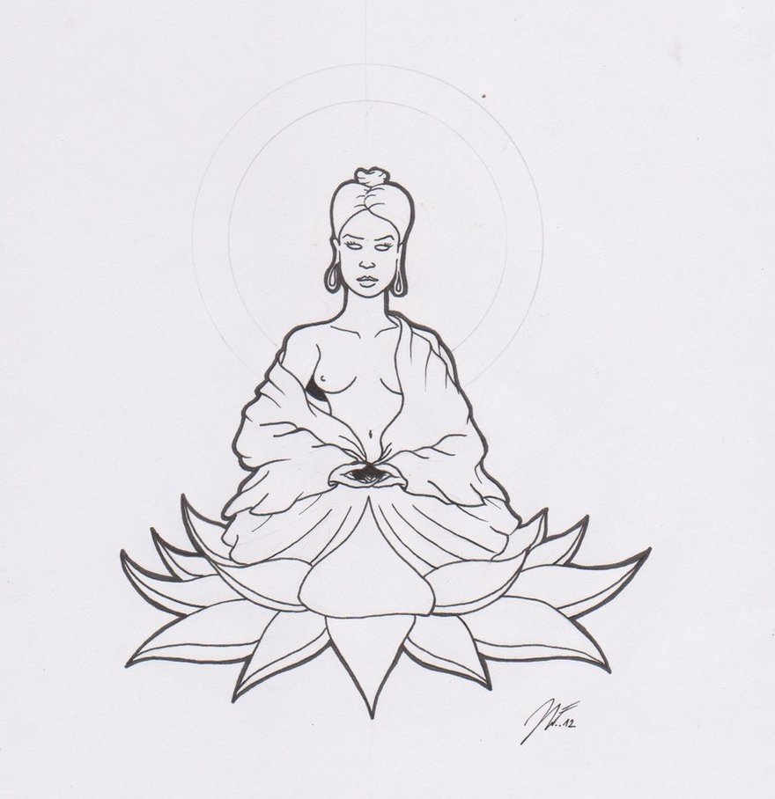

**A Self Care system for those that want to promote**

**Better Health**

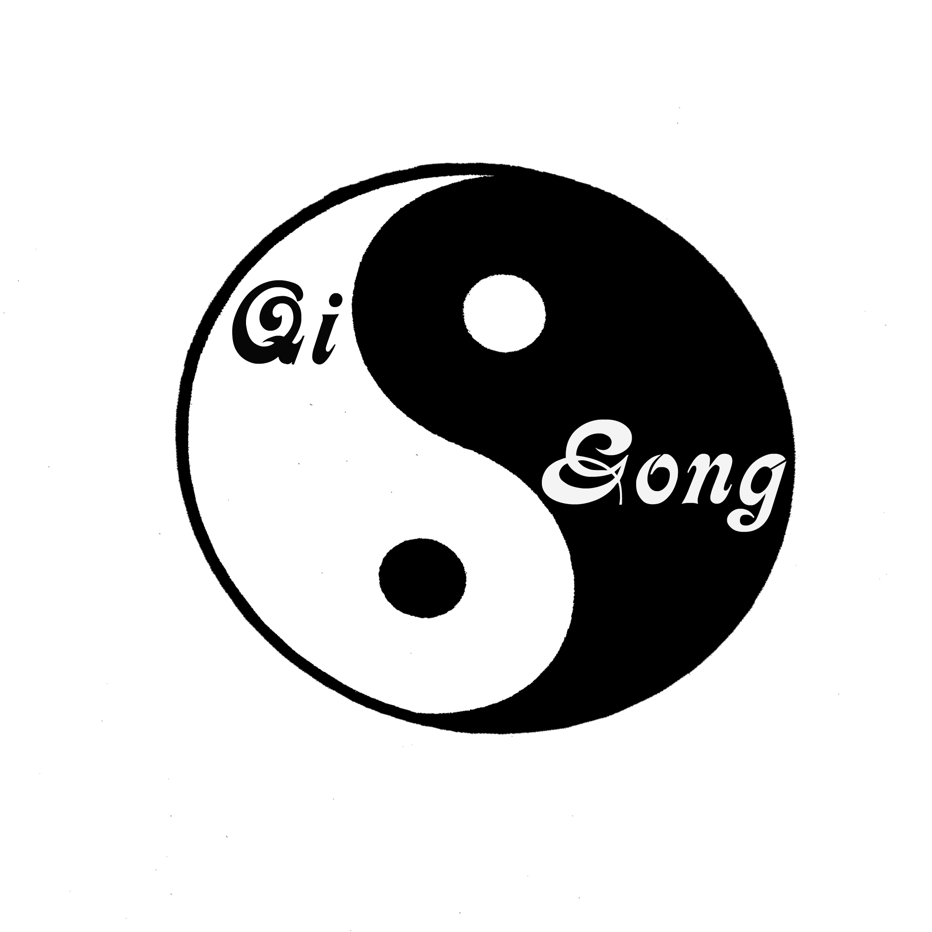

**Qi Gong** is not just a set of breathing exercises or stretches or a form you need to memorize, but it is composed of physical and mental personal training methods based on several principles:

* Intentional movements
* Rhythmic breathing
* Self Healing Massages
* Dietary Advise
* Focus
* Relaxation

Qi Gong is an excellent form of exercise for all people because of its gentle and soothing nature. This form of exercise can be adjusted to anyone’s personal needs and is perfectly suitable for people that recover from diseases, those that battle a disease or those that want to prevent it.

Anyone can do Qi Gong, regardless of age, ability, flexibility, or activity level. Qi Gong is also significantly effective in improving memory, immunity and balance, relieving pain, encouraging mobility, renewing energy, promoting your self-healing ability and reducing stress.

**Energy Training for Breast Cancer patients**

If you, or anyone you know, want to promote breast health, or if you have been diagnosed with breast cancer and you are currently undergoing treatments like radiation, surgery or chemotherapy, or if you are recovering from treatments and you want to build up more energy and power, learn how to relax whilst exercising: then this program is suitable for you.

Qi Gong Aruba offers a 10 week program of Energy Training for Breast Health starting on Thursday September 1st 2016 at Fantastic Gardens at 6 PM. Groups are limited to 10 participants. Cost of the entire program is 100 AWG, including a manual and a t-shirt.

For more information or to register, please call or Whatsapp us at 5939133. You can also visit us on Facebook or send an email to steraruba@gmail.com,

#### Energy Training for Breast Health



**Energy Training** is based on an ancient and proven form of preventive health care from the East called Qi Gong (Chee Gung). It is a practice of aligning breath, movement, and awareness for exercise, healing, and meditation. We practice this form of exercise to balance our bodies and minds and to build up the energies that flow and heal. Typically this practice involves rhythmic breathing, coordinated with slow stylized repetition of fluid movements, and a calm mindful state.